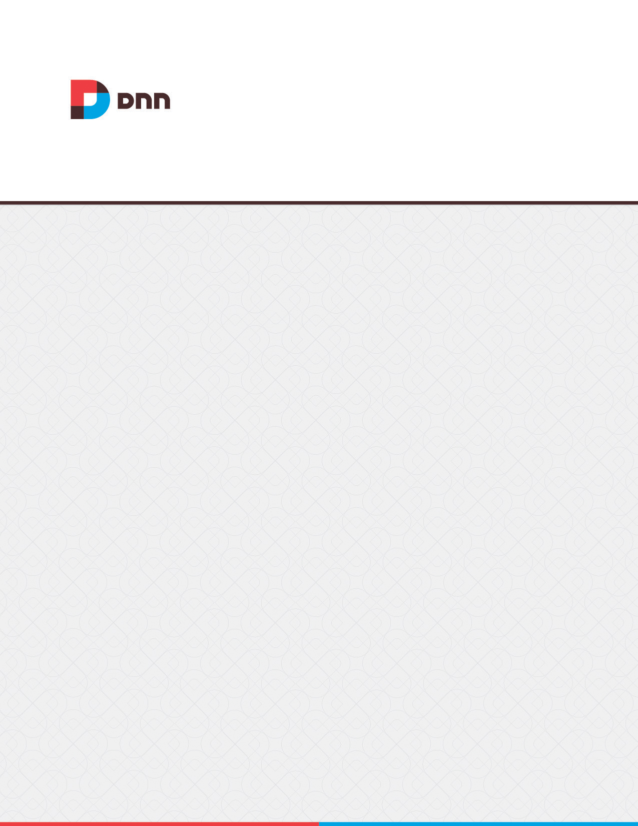

**Vendors 07.04.00  
User Manual**

Contents

**No table of contents entries found.**

# Vendors

The Vendors module manages vendor accounts, vendor banners and affiliate accounts.

Vendor accounts and banners created on the Admin > Advanced Settings > Vendors page are exclusive to the current site. Another instance of the Vendors module can be located on the Host > Vendors page to allow Super Users to create and manage banners that can be displayed on any site within this DNN installation.

Banners can be images, text or script. They can be displayed on the site using either the [BANNER] theme token or using the Banners module. Vendors collects banner statistics including tracking of clicks, views and impressions and tracks commission for banner advertising on other sites and commissions received from banner advertisement on this site.

The Vendors module can be added to any site page to enable users with view permissions to view, search and filter vendor accounts. DNN Platform users must be granted Edit Module permissions to create and manage vendors, banners and affiliate accounts. Evoq Content users must be granted Edit Content permissions to create and manage vendors, banners and affiliate accounts.

Vendors

## Adding a New Vendor

Administrators can add vendor accounts via the Admin > Advanced Settings > Vendors page. After completing the vendor details, users can unmark  a check box beside any address field to make it optional or mark  a check box is the field is required. These selections will be retained when adding and editing other vendor accounts. Note: Additional vendor details (logo, authorization, classifications, banners and affiliate referrals) are available once a new vendor is created. These can be completed by editing the vendor record.

## Managing Vendor Accounts

Vendor account details can be modified or permanently deleted when editing a vendor account on the Admin > Advanced Settings > Vendors page. A vendor logo and keywords (not currently implemented) can be added to new vendor accounts. Vendor accounts can also be authorized or unauthorized from this area.

## Filtering and Searching Vendors

Vendor accounts maintained on the Admin > Advanced Settings > Vendors page can be filtered by the first letter of the company name or by unauthorized accounts. Vendor accounts can also be searched by exact matches of email addresses or by all or part of the Vendor's company name.

## Deleting all Unauthorized Vendors

Administrators can permanently delete all unauthorized vendors by clicking the Delete Unauthorized Vendors button on the Admin > Advanced Settings > Vendors page. Deleting a vendor does not delete any related Vendor banners from the Admin > File Management page however the banners will no longer be displayed in the Banners module.

# Vendor Banners

Banner advertising can be created for individual vendor accounts maintained of Admin > Advanced Settings > Vendors page by adding a new banner when editing the vendor account.

A variety of different types of banners can be added which can then be displayed on the site using the Banners modules. Optional. In the Banner Group text box, enter a name to group this banner with other banners. The banner group can then be entered into the banners module to set it to only display banners in this group.

## Adding an Image Banner

Image banners can be added to a vendor account via the Banner Advertising section of the Admin > Advanced Settings > Vendors page when editing a vendor account. The banner name, type and image/link fields are mandatory for an image banner. If the Text/Script field below is left blank then the Banner Name is the alternate text for the banner. The banner type can be Banner, MicroButton, Button, Block, or Skyscraper. Associating this banner with a group of banners is optional. It allows users to restrict the banners displayed in the banners module to this group.

Complete any of the additional optional settings or update the banner now. Alternate text for this banner can be entered into the "Text/Script" which will display when a user places their mouse over this image. The banner link can be set at the "URL" field by choosing the URL or page that users will be taken to when they click on the banner, or the File to be displayed. If URL is selected and the text box is left empty then the link will go to the Vendors website. Any URL that is entered will also displayed below the banner.

Enter the CPM (cost per 1000 Impressions) or the once off cost. E.g. For every 1000 impressions of the banner the Vendor will charge the listed amount. Alternatively, the vendor may charge a flat fee for banner advertising. Enter the number of impressions the banner will display for. An impression is made each time a banner is displayed on the page.

Set a start and/or end date for the banner. And set the criteria by choosing And if the banner only expires if both the Impressions and the End Date has been met (i.e. The banner has reached its number of clicks AND a banner has expired) or choose Or if the banner expires if either the Impressions or the End Date has been met (i.e. The banner has reached its number of clicks or it has expired).

Once the banner has been updated it can be previewed by expanding the Banner Advertising section and choosing edit the banner.

## Adding a Script Banner

JavaScript banners can be added to a vendor account via the Banner Advertising section of the Admin > Advanced Settings > Vendors page when editing a vendor account. After entering a banner name and selecting "Script" as the banner type, users can skip the Image/Link, Width and Height fields and enter the script for this banner into the "Text/Script" text box. Complete any of the additional optional settings in the same way as for an image banner or update the banner now.

## Adding a Text Banner

Text banners can be added to a vendor account via the Banner Advertising section of the Admin > Advanced Settings > Vendors page when editing a vendor account. The Banner Name will be displayed at the top of the banner and as a link to the vendor's website or to the URL, Page or File as set at the URL field below. The banner type must be set to "Text". An image can optionally associated with this banner at the "Image/Link". This image isn't displayed on the banner; instead the image name is displayed as a link to view the image. Alternatively, select "URL (A Link to an External Resource)" to add a link to an image, file or page located on another website. The full URL will be displayed on the text banner.

Skip the Width and Height fields and enter the text for this banner into the "Text/Script" text box. HTML formatting is permitted. Complete any of the additional optional settings or update the banner now. The banner link can be set at the "URL" field by choosing the URL or page that users will be taken to when they click on the banner, or the File to be displayed. If URL is selected and the text box is left empty then the link will go to the Vendors website. Any URL that is entered will also displayed below the banner. Likewise the page number (e.g. 85) or the file ID number are displayed at the bottom of the banner. E.g. FileID=148

Complete the costing and scheduling fields and update the banner.

## Managing Banners

Vendor banners can be edited or permanently deleted via the Banner Advertising section of the Admin > Advanced Settings > Vendors page when editing a vendor account

## Viewing the Banner Status Report

A status report for each banner can be viewed in the Banner Advertising section of the Admin > Advanced Settings > Vendors page when editing a vendor. Each report displays the number views (the number of times a banner has been clicked on) and clicks (the number of times a banner has been displayed on a page) that a vendor banner has received. This information can then be sent to the vendor along with the Banner name, description, image name, number of CPM/Cost, number of impressions, state and end dates.

# Affiliate Accounts

One or more affiliate referral links can be created and associated with each Vendor. These accounts are used for tracking advertising of this site on other websites. DNN generates the link for other websites to use, so that it can track each time a visitor clicks through to the site, from an advertising website, so that the difficulty in collecting information for commissions to be paid can be easily managed. An affiliate report can be sent to affiliates providing details of the site they have been made an affiliate of and the URL link to be used.

## Adding an Affiliate

Administrators can add affiliates referrals via the Affiliate Referrals section when editing a vendor account. Each referral includes a Cost per Click commission amount that is paid to the vendor when a visitor is referred to the site and/or a Cost per Acquisition commission amount that is paid to the vendor when a visitor becomes a member of the site. Once the account is created, a link is generated which the vendor can add to their site. The number of clicks and acquisitions for the link are tracked and can be used to calculate the commission owing to the vendor.

## Managing Affiliates

Administrators can edit the details of an affiliate referral account or delete the account and all associated information via the Affiliate Referrals section when editing a vendor account.